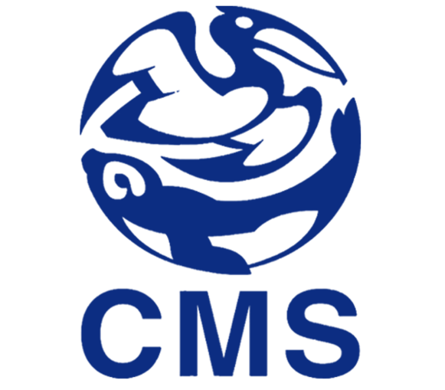

SMALL GRANTS PROGRAMME

PART B - Endorsement Form -

This form is to be signed by the CMS Focal Point of each country, where activities are planned as part of the project (host country). If there is more than one host country, please submit one endorsement form per country, together with the remainder of the application by 30 November 2013 at the latest.
Submission via email (scanned copies) is preferred (secretariat@cms.int, as pdf or MS Word file). Submissions sent via post have to reach the Secretariat by the same date and can be sent to: UNEP/CMS Secretariat, UN Campus, Platz der Vereinten Nationen 1, 53113 Bonn, Germany.
The Revised Guidelines for the Operation of the Small Grants Programme are available in the document UNEP/CMS/Conf.10.43, on the CMS website: www.cms.int.

For any queries please do not hesitate to contact Johannes Stahl (jstahl@cms.int) or Laura Aguado (laguado@cms.int) at the UNEP/CMS Secretariat.
- Please use the grey fields for answers. –
To be filled by the CMS Focal Point

Host country:

Agency submitting the application:

Project title (not exceeding 10 words):

Institution/agency:

Title and name:

Email address:

I have read the Revised Guidelines for the Operation of the Small Grants Programme (UNEP/CMS/Conf.10.43) and reviewed the above-mentioned project, and would herewith like to endorse it for support from the CMS Small Grants Programme.

Date

Signature

