ADDENDUM 2

SUMMARY

OF THE MULTI-SPECIES ACTION PLAN TO CONSERVE AFRICAN-EURASIAN VULTURES (VULTURE MSAP)

CONSERVATION OF AFRICAN-EURASIAN VULTURES

UNEP/CMS/COP12/DOC.24.1.4

Introduction

Vultures are a characteristic, distinctive and spectacular component of the biodiversity of the environments they inhabit. They also provide critical ecosystem services by cleaning up carcasses and other organic waste in the environment, which has huge ramifications for the spread of diseases in both wild and domestic animals, and pathogenic risks to humans.

The IUCN Red List status of African-Eurasian vultures has seen drastic changes for the worse in recent years: the majority of species are listed as Critically Endangered, the highest category of threat, indicating a very high risk of extinction in the wild. They are the most threatened group of terrestrial migratory birds on the planet. Unless effective conservation action is implemented or expanded across the range of these birds, there is a significant likelihood that several of these species will indeed become extinct in the near future. The main reason for this is major population declines driven by poisoning, both intentional and otherwise. However, several other threats have been identified.

Recent studies of the movement of vultures using satellite telemetry have shown the vast cyclical movements undertaken by this group of species. Accordingly, conservation actions can only be effective if implemented at the flyway level, which requires a broad approach and the engagement of all Range States. This realization, and the wider appreciation of the seriousness of the African Vulture Crisis, in addition to that already known in Asia, and increasing threats to vultures elsewhere, have been key catalysing factors that led to swift international agreement on the urgent need to develop a Multi-species Action Plan to Conserve African-Eurasian Vultures (Vulture MsAP) under the Convention on the Conservation of Migratory Species of Wild Animals (CMS).

The Vulture MsAP, the result of extensive consultation with stakeholders, conservation and species experts, has the following aims:

- To rapidly halt current population declines in all species covered by the Vulture MsAP;
- To reverse recent population trends to bring the conservation status of each species back to a favourable level;
- To provide conservation management guidelines applicable to all Range States covered by the Vulture MsAP.

Scope and rationale

The Vulture MsAP aims to provide a comprehensive, strategic conservation Action Plan covering the geographic ranges of all 15 species of migratory African-Eurasian vultures and to promote concerted, collaborative and coordinated international actions towards the recovery of these populations to acceptable levels by 2029. The species that are the focus of this plan are:

Species | Range | Global Threat Level (Red List category)¹
Bearded Vulture Gypaetus barbatus | Europe, Asia, Africa | NT
Egyptian Vulture Neophron percnopterus | Europe, Asia, Africa | EN
Red-headed Vulture Sarcogyps calvus | Asia | CR
White-headed Vulture Trigonoceps occipitalis | Africa | CR
Hooded Vulture Necrosyrtes monachus | Africa | CR
Himalayan Griffon Gyps himalayensis | Asia | NT
White-rumped Vulture Gyps bengalensis | Asia | CR
White-backed Vulture Gyps africanus | Africa, (Europe) ² | CR
Indian Vulture Gyps indicus | Asia | CR
Slender-billed Vulture Gyps tenuirostris | Asia | CR
Cape Vulture Gyps coprotheres | Africa | EN
Rüppell's Vulture Gyps rueppelli | Africa, (Europe) ² | CR
Griffon Vulture Gyps fulvus | Europe, Asia, Africa | LC
Cinereous Vulture Aegypius monachus | Europe, Asia, (Africa) ² | NT
Lappet-faced Vulture Torgos tracheliotos | Africa, Asia | EN
Notes:
¹ CR = Critically Endangered; EN = Endangered; NT = Near Threatened; LC = Least Concern.
² Cinereous Vultures occur irregularly and in very small numbers in Africa; Rüppell's and White-backed Vultures similarly in Europe (although perhaps more regularly).

These 15 species are all listed in Annex I of the CMS Memorandum of Understanding on the Conservation of Migratory Birds of Prey (Raptors MOU). The remaining Old World vulture species, Palm-nut Vulture Gypohierax angolensis, is excluded from the Vulture MsAP because it is not considered a migratory species and is treated as Least Concern in the Red List. A total of 128 Range States host populations of one or more species of African-Eurasian vultures and are included within the geographic range of the Vulture MsAP.

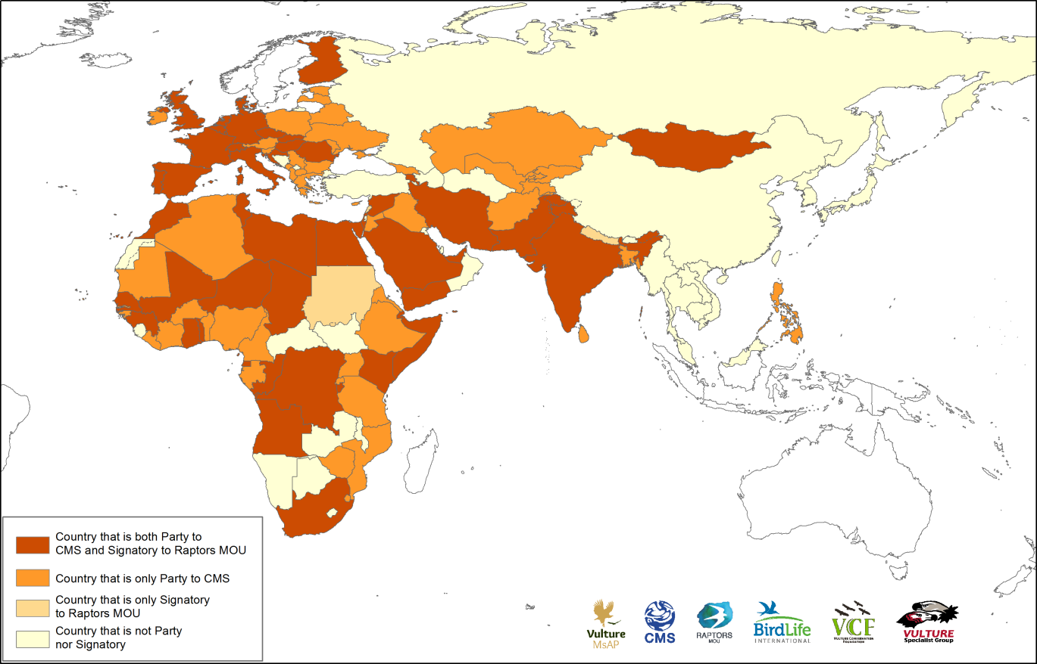

Map showing Vulture MsAP Range States of Africa and Eurasia (shaded), together with Parties to CMS and Signatories to the Raptors MOU.

The mandate for the Vulture MsAP was established at the 11th CMS Conference of Parties (COP11) in November 2014. CMS Resolution 11.14 on the Programme of Work on Migratory Birds and Flyways was adopted, and Action 9 of the Resolution, under the Species-specific Conservation Actions section, seeks to promote the development, adoption and implementation of species action plans for priority species in line with CMS priorities for concerted and cooperative action. The mission was to bring together representatives of Range States, partners and interested parties, to develop a Vulture MsAP for submission to CMS COP12, scheduled to be held in October 2017.

THREATS

Not every factor that kills a vulture is a threat to the entire population. However, no threats or causes of mortality are ignored in this Vulture MsAP, but some are considered local or of limited impact, with evidence suggesting that they cause individual mortality rather than population-level declines.

Conservation actions included in the Vulture MsAP generally focus on addressing one or more threats and/or their root causes, taking account of the distribution and ecology of the species. The threats are described briefly below; the figure presents their degree of threat to vultures in each region or sub-region of the MsAP range.

Poisoning
- Unintentional secondary poisoning – human-wildlife conflict. Vultures are killed when feeding on poisoned bait set for mammalian predators as a result of human-predator conflicts or for the control of problem animals, e.g. feral dogs.
- Unintentional secondary poisoning – non-steroidal anti-inflammatory drugs (NSAIDs) and other veterinary medicines. This threat has caused massive declines in the populations of a range of Asian vultures and also poses a potential threat elsewhere within the Vulture MsAP range. Mortality occurs when birds feed on the carcasses of animals treated with a range of NSAIDs that are highly toxic to vultures.
- Unintentional secondary poisoning – lead poisoning. Lead residues in carcasses and gut-piles from ammunition used by hunters or livestock owners to kill animals pose a substantial risk of poisoning if these are available for vultures to feed on.
- Intentional poisoning – belief-based use. The killing of vultures for the use of their body parts for various beliefs is known to be widespread in West, East and Southern Africa.
- Intentional poisoning – sentinel poisoning. Poachers wishing to prevent detection of their illegal killing of elephants and other large game animals in Africa deliberately poison the carcasses of the poached animals to destroy large numbers of vultures whose soaring behaviour can indicate the location of such activities to law enforcement officials.

Mortality caused by energy infrastructure
- Electrocution on energy infrastructure. In large parts of the Vulture MsAP range, vultures are at risk of being electrocuted when perching, roosting or nesting on unsafe energy infrastructure, particularly power distribution poles.
- Collisions with energy infrastructure (powerlines and wind turbines). Poorly planned and located energy infrastructure, particularly power lines and wind turbines, can impose substantial impacts on vultures as a result of collision which can cause serious injury or death. Increasing use of renewable energy sources such as wind has generated extensive plans for wind turbine installations in many parts of the Vulture MsAP range, with a corresponding increase in the risk of vulture mortalities due to collision with these structures.

Other threats
A range of other factors has been shown or suspected to cause vulture mortality and in some cases population declines. Habitat degradation may include broad-scale effects on ecosystems, or more localized impacts including loss of nest trees or roosting sites. Decline of food availability refers to the reduction in appropriate levels of safe food to sustain healthy vulture populations. Direct persecution (non-poison) refers to a range of impacts on vultures, involving illegal killing, taking and trade. Human disturbance covers a range of damaging activities, such as construction of infrastructure, agriculture, aviation, mining, blasting and quarrying.

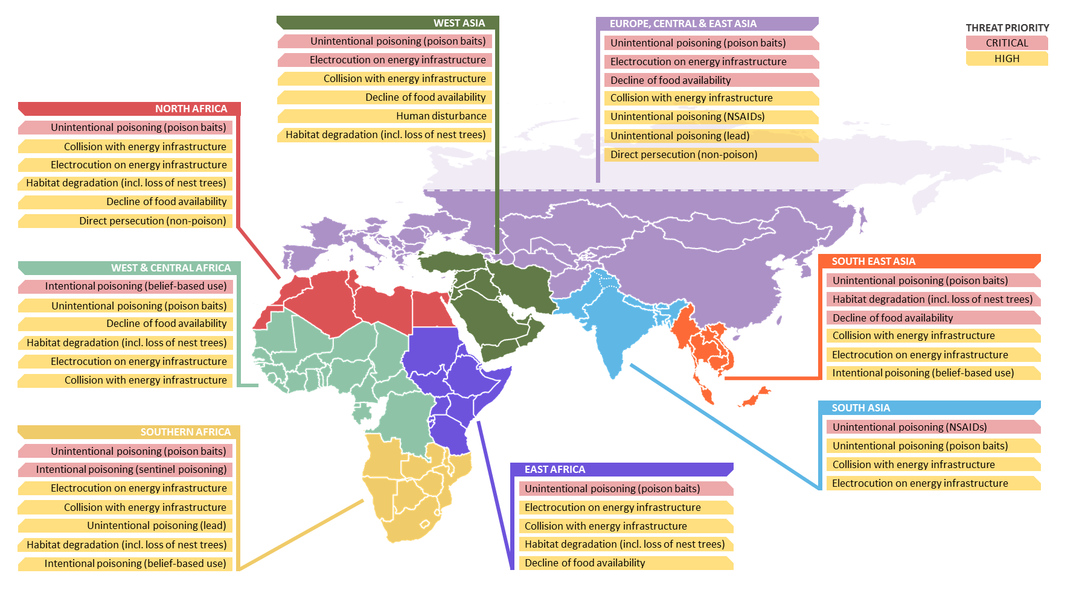
Map indicating priority threats for the Vulture MsAP range. The Russian Federation is a Range State, but vultures are restricted to the North Caucasus and Altai-Sayan regions (the latter being near the borders of Mongolia and Kazakhstan); more northerly parts of the Federation are not shown.
STAKEHOLDERS AND POTENTIAL COLLABORATORS

With so many Range States, space does not permit a catalogue of stakeholders for each country even in the full Vulture MsAP. However, the main categories of stakeholders have been identified. They include relevant international conventions and their working groups and task forces; national and international Conservation NGOs; research institutions, universities and academics; regional and sub-regional economic commissions; donors, banks and other financial supporters; the private sector (e.g. (agro)chemical, pharmaceutical, energy, agriculture, tourism, mining, abattoirs); Government (national and local) ministries or authorities concerned with wildlife, agriculture, livestock and veterinary services/animal health, (human) health, energy, customs and border controls; local communities (grassroots groups and individuals, perhaps especially pastoral communities); judiciary and law enforcement agencies; and a range of others including religious leaders, traditional healers/medicine practitioners, the media, celebrities, the military and hunters.

Vulture conservationists cannot solve many of the threats on their own, so it is vital that they engage with the many other stakeholders identified here, with the aim of developing strategic alliances to achieve shared goals. Many conservation and non-conservation stakeholders that may not be directly concerned with vultures nevertheless have priorities that are affected by the same threats as those suffered by vultures. An example is health authorities dealing with belief-based use of vultures by people for various reasons, which are at best medically ineffective and at worst potentially lethal if the body parts used were obtained from poisoned birds. Another is big cat or elephant conservationists dealing with poisoning and/or poaching which also kills many vultures.

POLICIES, LEGISLATION AND ACTION PLANS RELEVANT FOR MANAGEMENT

A number of international conventions and other intergovernmental policy frameworks exist that provide a platform for tackling the main threats to vulture populations. Yet these conventions, with the exception of work through CMS, make little or no reference to vultures. Responsibilities are, however, placed on countries by certain international processes and relevant conventions, such as the United Nations Sustainable Development Goals, United Nations Environment Assembly, Convention on Biological Diversity and the Aichi Targets, UN Convention to Combat Desertification, and Convention on the International Trade of Endangered Species of Wild Fauna and Flora. Regional organizations such as the European and African Unions may also promote and enforce relevant actions.

These, together with the International Union for the Conservation of Nature (IUCN) through its World Conservation Congresses, provide frameworks, action plans, guidelines, international policies and resolutions around the main threats to vultures (such as poisoning and chemical use, and mortality caused by power grid infrastructure) and/or actions needed to conserve them, including conservation (captive) breeding and reintroduction.

OBJECTIVES, KEY ISSUES AND ASSOCIATED ESSENTIAL ACTIONS

To achieve the three aims (see above) of the Vulture MsAP, the following objectives are proposed:

- To achieve a significant reduction in mortality of vultures caused unintentionally by toxic substances used (often illegally) in the control and hunting of vertebrates;
- To recognize and minimize mortality of vultures by non-steroidal anti-inflammatory drugs (NSAIDs) and occurrence and threat of toxic NSAIDs throughout the range covered by the Vulture MsAP;
- To ensure that CMS Resolution 11.15 on the phasing out the use of lead ammunition by hunters is fully implemented;
- To reduce and eventually to halt the trade in vulture parts for belief-based use;
- To reduce and eventually to halt the practice of sentinel poisoning by poachers;
- To substantially reduce vulture mortality caused by electrocutions linked to energy generation and transmission infrastructure;
- To substantially reduce vulture mortality caused by collisions linked to energy transmission and generation infrastructure;
- To ensure availability of an appropriate level of safe food to sustain healthy vulture populations;
- To ensure availability of suitable habitat for vultures to nest, roost and forage;
- To substantially reduce levels of direct persecution and disturbance of vultures caused by human activities;
- To support vulture conservation through cross-cutting actions that contribute to addressing knowledge gaps;
- To advance vulture conservation by effective promotion and implementation of the Vulture MsAP.

The Vulture MsAP presents a detailed framework for action consisting of the 12 objectives listed above, together with high-level indicators and targets for their achievement. These would be achieved through realisation of 33 associated results and execution of 124 actions. The Vulture MsAP extends over 12 years and will require a concerted effort throughout this period to ensure its successful implementation.

Each of the 124 actions is assigned a level of priority based on the scale, scope and urgency of the overarching threat which it is intended to address and is categorized as either Direct Conservation Action, Education and Awareness, Policy and Research or Research and Monitoring. As a result, 17 are identified as Essential, as their immediate implementation is considered most important to ensure that progress towards achieving the goal of the Vulture MsAP is made as quickly as possible. The Essential actions focus on addressing specific aspects of the critical threats, cross-cutting conservation actions that can be implemented by most Range States to the benefit of vultures, and the establishment of a functional framework for the implementation of the plan across the entire range.

INTERNATIONAL COORDINATION OF IMPLEMENTATION

The need for an Implementation Plan

An Implementation Plan is a management tool, which requires key stakeholders to think through the way in which planned actions can be put into practice. This planning is proactive, instead of reactive, which allows best practices to be applied with the aim of ensuring the most effective stewardship of time and resources to deliver the anticipated results in a timely manner. It also allows an opportunity to consider vital aspects such as international coordination; the securing of resources; and an effective communication strategy.

Framework for coordination

A functional structure to facilitate implementation of the Vulture MsAP is essential to drive the process forward following its anticipated adoption at CMS COP12. The proposed coordination structure for the implementation can be summarised as follows:

Coordinating Unit of the CMS Raptors MOU: Overall responsibility for guiding and overseeing the implementation of the Vulture MsAP, including spearheading efforts to secure resources, Coordinator recruitment and stakeholder liaison.
Overarching Coordinator: Responsibility for, and oversight of the day-to-day implementation of the Vulture MsAP; finding the necessary resources to fund this position is a priority.
Regional Coordinators: The appointment of 3–4 Regional Coordinators covering Europe, Asia, Africa and the Middle East would further assist in the implementation of the Vulture MsAP.
Vulture MsAP Working Group: An efficient and effective mechanism for two-way communications with all Range States, partners and interested parties, to ensure implementation of the Vulture MsAP.
Vulture MsAP Steering Group: Members are expected to act as ‘champions’ and to take responsibility for leading and driving forward discrete tasks, relevant to their region.
Regional Vulture Committees: Established by the Regional Coordinators to facilitate communications within the regions.
National Vulture Task Forces: Considered an extremely effective way to bring together representatives from relevant government departments and other stakeholders to develop a National Vulture Conservation Strategy.
Public support: Consideration should be given to the establishment of a structure through which interested individuals and organizations can express their support and follow progress. Potential synergies with existing initiatives such as International Vulture Awareness Day could assist in making this possible without requiring substantial additional resources.

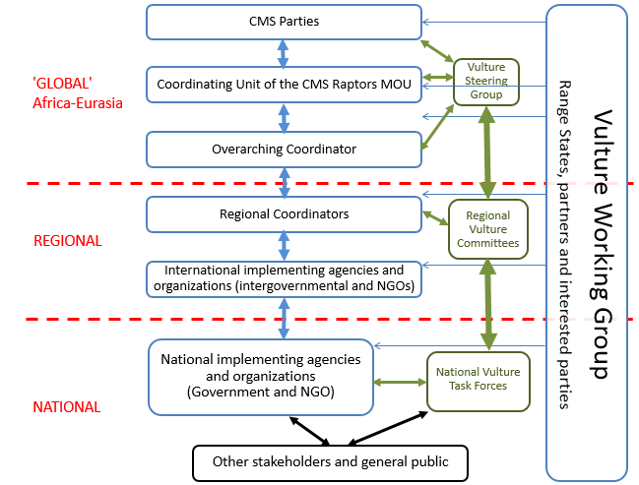

Proposed coordination framework to oversee implementation of the Vulture MsAP. Arrows indicate reporting or supervision/advisory relationships. Green arrows and boxes indicate primarily advisory structures; blue arrows and boxes primarily concern implementation and reporting.

National strategies and action plans

The Vulture MsAP has been drafted to ensure that it is relevant to each and every one of the 128 Range States covered by the plan. However, it is anticipated that each national government may decide to utilize the Vulture MsAP to develop a tailored National Vulture Conservation Strategy (see above) focussed solely on the species that occur within their jurisdiction and to address the specific threats each of these species are facing. This is a critically important step to be taken by countries hosting internationally important breeding, wintering or migrant species. Ideally, National Vulture Conservation Strategies should be developed to complement and support existing National Biodiversity Strategies and Action Plans already in place under the Convention on Biological Diversity.

Fundraising and resource mobilization

Developing a comprehensive budget and fundraising plan is beyond the scope of the Vulture MsAP, which instead focuses on the key principles that should guide budgeting, fundraising and resource mobilisation, and also identifies opportunities in relation to specific issues associated with vulture conservation.

Costs relating to the implementation of the Vulture MsAP can be considered in terms of those that relate to the coordination structure, and those required to implement the practical conservation actions. It is important to seek pledges of funding, most likely from CMS Parties, for the coordination structure and its operations at the earliest possible opportunity; as one of its key responsibilities, this structure will assist with fundraising for the practical implementation of the Vulture MsAP.

Further information

Interested readers of this Summary are strongly encouraged to consult the unabridged Final Draft Vulture MsAP, which can be downloaded from the CMS COP12 webpage.

The Vulture MsAP also contains information on, or links to, existing plans and policies focused on relevant threats, individual species or groups of species. Two of these documents were developed concurrently with the development of the Vulture MsAP and were consulted extensively with regard to the two species concerned. These are:

- Flyway Action Plan for the Conservation of the Balkan and Central Asian Populations of the Egyptian Vulture²
- Flyway Action Plan for the Conservation of the Cinereous Vulture³

A Blueprint for the Recovery of Asia’s Critically Endangered Gyps Vultures⁴ was developed by the Saving Asia’s Vultures from Extinction (SAVE) consortium. It is annually updated by SAVE members and provides clear guidance in terms of regional vulture conservation; the recommended actions in the Vulture MsAP reflect this.

All three documents are included as Annexes to the Vulture MsAP.

⁻⁴ http://www.cms.int/en/document/multi-species-action-plan-conserve-african-eurasian-vultures-vulture-msap

